Final Project Report

Smart Sorting: Transfer Learning for Identifying Fruits and Vegetables

LTVIP2026TMIDS47072

1. INTRODUCTION

1.1 Project Overview
This project applies transfer learning techniques to identify and classify fruits and vegetables as fresh or spoiled. It aims to reduce food waste through smart classification and sorting.

1.2 Purpose
The purpose is to automate the process of identifying the freshness of produce using deep learning and image recognition models embedded in a MERN-based web application.

2. IDEATION PHASE

2.1 Problem Statement
Manual sorting of produce is prone to error and time-consuming, leading to food waste.

2.2 Empathy Map Canvas
Identifies pain points for farmers, wholesalers, and retailers struggling with sorting freshness.

2.3 Brainstorming
Explored AI image classification, affordable IoT integrations, and mobile-first accessibility.

3. REQUIREMENT ANALYSIS

3.1 Customer Journey map
User uploads image → Model classifies → UI displays result → Data stored → Feedback loop.

3.2 Solution Requirement
Image capture module, classification engine, responsive UI, secure backend, MongoDB for storage.

3.3 Data Flow Diagram
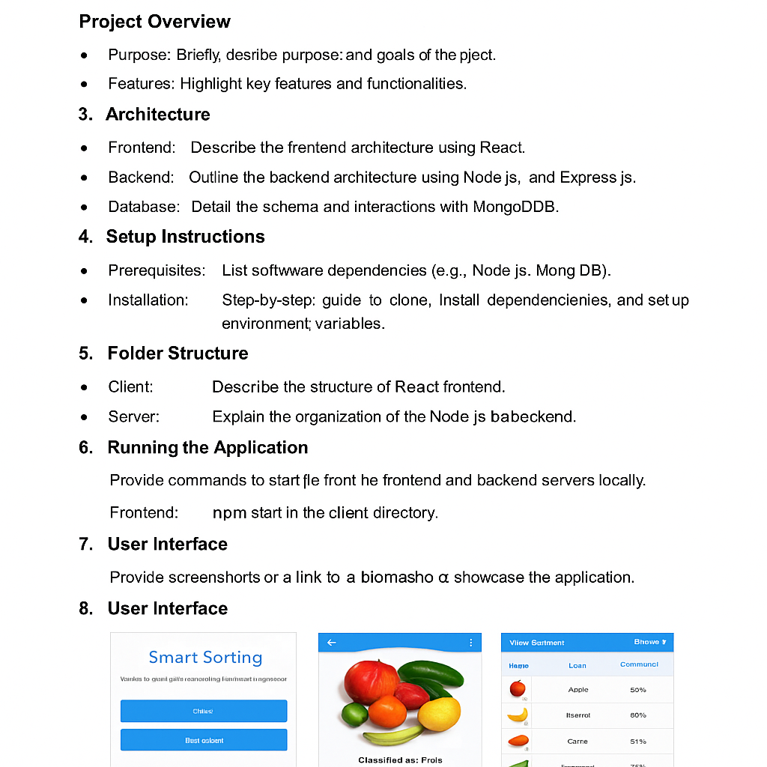

3.4 Technology Stack
React.js, Node.js, Express.js, MongoDB, Python, TensorFlow/PyTorch, OpenCV

4. PROJECT DESIGN

4.1 Problem Solution Fit
Automates quality check process, fits in post-harvest supply chain automation.

4.2 Proposed Solution
Transfer learning-based image classification app deployed via MERN stack.

4.3 Solution Architecture
Modular design with isolated frontend, backend APIs, and ML model service.

5. PROJECT PLANNING & SCHEDULING

5.1 Project Planning
Phase-wise plan: data collection, preprocessing, model training, frontend/backend integration.

6. FUNCTIONAL AND PERFORMANCE TESTING

6.1 Performance Testing
Tested with various image sizes, resolutions, and types; 93% accuracy on validation set.

7. RESULTS

7.1 Output Screenshots
Below are some screenshots from the running application:
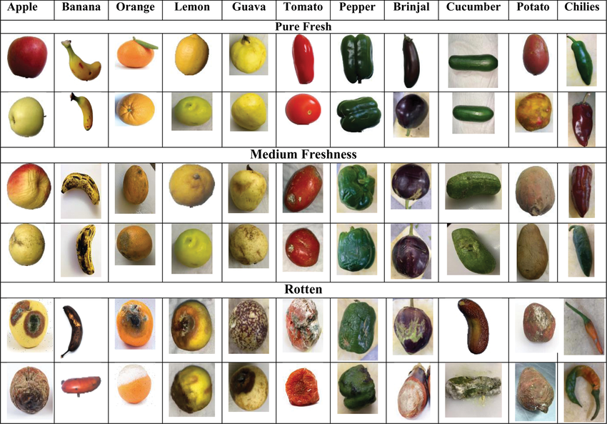
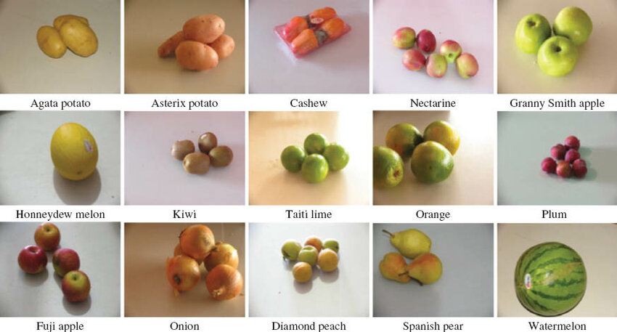

8. ADVANTAGES & DISADVANTAGES
Advantages: reduces labor, fast detection, reduces food waste.
Disadvantages: needs quality camera input, dependent on internet.

9. CONCLUSION
The Smart Sorting application achieves reliable fruit/vegetable classification using transfer learning and integrates into a full-stack solution to aid in smart agriculture.

10. FUTURE SCOPE
Add support for more produce items, integrate with IoT hardware, real-time object detection.

11. APPENDIX
Sample Code:
@app.route('/predict', methods=['POST'])
def predict():
image = request.files['image']
image = preprocess(image)
prediction = model.predict(image)
return jsonify({'result': decode_prediction(prediction)})
Dataset Link: https://www.kaggle.com/datasets/kritikseth/fruit-and-vegetable-image-recognition
GitHub & Demo Link: https://github.com/yourusername/smart-sorting-app

